ROAD ACCIDENT ANALYSIS VALIDATION REPORT
SQL QUERIES :

CY Casualties
SELECT SUM(Number_of_Casualties) AS CYCasualties
from road_accident
where YEAR(accident_date)='2022'

OUTPUT
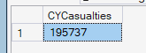

CY Accidents

SELECT COUNT(distinct Accident_Index) AS CY_Accident
FROM road_accident
WHERE YEAR(Accident_Date) = '2022';

OUTPUT
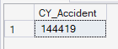

CY Fatal Casualities

SELECT sum(Number_of_Casualties) AS CY_Fatal_Accident
FROM road_accident
WHERE YEAR(Accident_Date) = '2022' AND Accident_Severity='Fatal'

OUTPUT
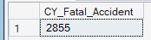

CY Serious Casualties

SELECT sum(Number_of_Casualties) AS CY_Serious_Casualties
FROM road_accident
WHERE YEAR(Accident_Date) = '2022' AND Accident_Severity='Serious'

OUTPUT
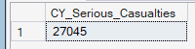

CY Slight Casualties

SELECT sum(Number_of_Casualties) AS CY_Slight_Casualties
FROM road_accident
WHERE YEAR(Accident_Date) = '2022' AND Accident_Severity='Slight'

OUTPUT
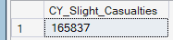

Casualties by Vehicle Type

SELECT
CASE
WHEN Vehicle_Type IN ('Agricultural vehicle') THEN 'Agriculture'
WHEN Vehicle_Type IN ('Car', 'Taxi/Private hire car') THEN 'Car'
WHEN Vehicle_Type IN ('Motorcycle 125cc and under', 'Motorcycle 50cc and under', 'Motorcycle over 125cc and up to 500cc', 'Motorcycle over 500cc', 'Pedal cycle') THEN 'Bike'
WHEN Vehicle_Type IN ('Bus or coach (17 or more pass seats)', 'Minibus (8 - 16 passenger seats)') THEN 'Bus'
WHEN Vehicle_Type IN ('Van / Goods 3.5 tonnes mgw or under', 'Goods 7.5 tonnes mgw and over', 'Goods over 3.5t. and under 7.5t') THEN 'Van'
ELSE 'Others'
END AS Vehicle_group,
SUM(Number_of_Casualties) AS CY_Casualties
FROM dbo.road_accident
WHERE YEAR(Accident_Date) = 2022
GROUP BY
CASE
WHEN Vehicle_Type IN ('Agricultural vehicle') THEN 'Agriculture'
WHEN Vehicle_Type IN ('Car', 'Taxi/Private hire car') THEN 'Car'
WHEN Vehicle_Type IN ('Motorcycle 125cc and under', 'Motorcycle 50cc and under', 'Motorcycle over 125cc and up to 500cc', 'Motorcycle over 500cc', 'Pedal cycle') THEN 'Bike'
WHEN Vehicle_Type IN ('Bus or coach (17 or more pass seats)', 'Minibus (8 - 16 passenger seats)') THEN 'Bus'
WHEN Vehicle_Type IN ('Van / Goods 3.5 tonnes mgw or under', 'Goods 7.5 tonnes mgw and over', 'Goods over 3.5t. and under 7.5t') THEN 'Van'
ELSE 'Others'
END;

OUTPUT
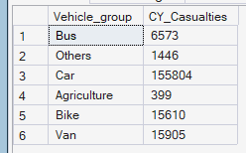

CY Casualties Monthly Trend
For Year 2022

select DateName(MOnth,Accident_Date)as Month_Name,
sum(Number_of_Casualties)As 'CY Casualties'
from road_accident
where YEAR(Accident_Date)= 2022
Group by Datename (Month,Accident_Date)

OUTPUT
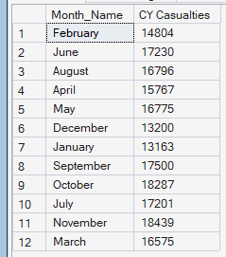

For Year 2021

select DateName(MOnth,Accident_Date)as Month_Name,
sum(Number_of_Casualties)As 'CY Casualties'
from road_accident
where YEAR(Accident_Date)= 2021
Group by Datename (Month,Accident_Date)

OUTPUT
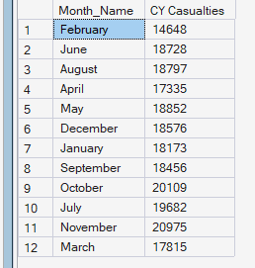

Casualties by Road Type

select Road_Type,
sum(Number_of_Casualties)as CY_Casualties from road_accident
where Year(Accident_Date)=2022
Group by Road_Type

OUTPUT
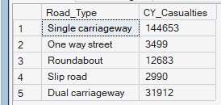

Casualties by Urban/Rural

SELECT
Urban_or_Rural_Area,
CAST(SUM(Number_of_Casualties) AS DECIMAL(10,2)) * 100 /
(SELECT CAST(SUM(Number_of_Casualties) AS DECIMAL(10,2))
FROM road_accident
WHERE YEAR(Accident_Date) = 2022) AS Percentage_Casualties
FROM road_accident
WHERE YEAR(Accident_Date) = 2022
GROUP BY Urban_or_Rural_Area;

OUTPUT
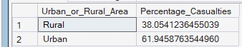

Casualties by (Day/Night) Light Condition

SELECT
CASE
WHEN Light_Conditions IN ('Daylight') THEN 'Day'
WHEN Light_Conditions IN ('Darkness - lighting unknown', 'Darkness - lights lit', 'Darkness - lights unlit', 'Darkness - no lighting' ) THEN 'Night'
ELSE 'Unknown'
END AS [Light_condition],

CAST(
SUM(No_of_Casualties) * 100.0 /
(SELECT SUM(Number_of_Casualties)
FROM dbo.road_accident
WHERE YEAR(Accident_Date) = 2022)
AS DECIMAL(10,2)) AS CY_Casualties_PCT

FROM dbo.road_accident
WHERE YEAR(Accident_Date) = 2022
GROUP BY
CASE
WHEN Light_Conditions IN ('Daylight') THEN 'Day'
WHEN Light_Conditions IN (
'Darkness - lighting unknown',
'Darkness - lights lit',
'Darkness - lights unlit',
'Darkness - no lighting'
) THEN 'Night'
ELSE 'Unknown'
END;

OUTPUT
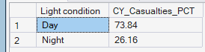

Top 10 Locations by Casualties

Select top 10 Local_Authority_District,sum(Number_of_Casualties)
as Total_casualties
from road_accident
group by Local_Authority_District
order by Total_Casualties DESC

OUTPUT
